For Office of the Governor Use Only

Project: _____________________

Community: __________________

Date: _______________________

Application Fee Enclosed



Texas Enterprise Fund
Application

Office of the Governor

Governor Abbott is committed to keeping Texas No. 1 in the nation for job creation, and to creating even more jobs and greater economic opportunity for all Texans. Month after month, the Lone Star State tops rankings for business climate, and job growth. Texas is a leading state for Fortune 500 and 1000 corporate headquarters and grew its exports by 6 percent in 2012 to remain the No. 1 exporting state in the country for the 11th year in a row. It’s no wonder Texas was named by Forbes as the “Best State for Jobs” and is also ranked as the No. 1 state on Forbes’ list for growth prospects and economic climate.

The Texas Enterprise Fund was established at the request of former Governor Rick Perry, and was passed through the Legislature with the support of the Lieutenant Governor and Speaker of the House in 2003. Using this economic development tool, Texas has been able to respond quickly and aggressively to opportunities to attract new businesses and expand existing ones, bringing approximately 70,000 jobs to Texas.

The Texas Enterprise Fund provides Governor Abbott and state leaders with a “deal-closing fund” that has the flexibility and resources to help strengthen Texas’ economy. The fund can be used for a variety of economic development projects including infrastructure development, community development, job training programs and business incentives. Before funds can be awarded, the Governor, Lieutenant Governor and Speaker must unanimously agree to support the use of the Texas Enterprise Fund for each project, following a thorough application and evaluation process.

The Texas Enterprise Fund is used primarily to attract new businesses to Texas or to assist with the substantial expansion of an existing business as part of a competitive recruitment process.

To be eligible for Texas Enterprise Fund support, a project must demonstrate a significant return on the state’s investment and strong local support. The review process evaluates a variety of factors associated with each project, including job creation and wages, capital investment, financial strength of the applicant, the applicant’s business history, analysis of the relevant business sector, and public and private sector financial support.

If you have a project that can benefit from the Texas Enterprise Fund, an application must be submitted to the Office of the Governor, Economic Development and Tourism division that provides information on how funds are to be utilized and how the proposed project meets the criteria of the program. If a project receives Texas Enterprise Funds, a performance document will be adopted which will include default provisions to ensure that Texas taxpayer funds are spent effectively and efficiently.

For more information on the Texas Enterprise Fund, contact Texas Business Development at (512) 936-0100 or visit http://governor.state.tx.us/ecodev/financial_resources/texas_enterprise_fund.

INSTRUCTIONS

Submit a completed application to the Office of the Governor. If application is submitted through regular mail, mail the application to Office of the Governor, Attention Financial Services, Post Office Box 12878, Austin, Texas 78711-2878. If through overnight delivery, send to Office of the Governor, Attention Financial Services, 1100 San Jacinto, Austin, Texas 78701. Include all requested information for all sections since any performance documents or State Agreements developed will use details represented in this application. Be accurate and thorough to avoid delays in processing. Where no response is possible, it should be marked N/A. Attachments and additional pages are not required unless specifically requested in the application. Any necessary supplemental information will be requested as a follow-up document. Original signatures must accompany the completed application. Always use the most current application found at http://governor.state.tx.us/files/ecodev/tefapp.doc.

CERTIFICATION OF APPLICATION – COMMUNITY

Authorized Community Representative
First Name ____ Last Name
Title
Organization
Street Address
Mailing Address
City State TX Zip -
Phone Number Fax Number
Mobile Number Website
Email Address

To the best of my knowledge and belief, the information contained in this Texas Enterprise Fund Application is true and correct, as evidenced by my signature below.

Signature Date
(Community Representative)

INSTRUCTIONS

Submit a completed application to the Office of the Governor. If application is submitted through regular mail, mail the application to Office of the Governor, Attention Financial Services, Post Office Box 12878, Austin, Texas 78711-2878. If through overnight delivery, send to Office of the Governor, Attention Financial Services, 1100 San Jacinto, Austin, Texas 78701. Include all requested information for all sections since any performance documents or State Agreements developed will use details represented in this application. Be accurate and thorough to avoid delays in processing. Where no response is possible, it should be marked N/A. Attachments and additional pages are not required unless specifically requested in the application. Any necessary supplemental information will be requested as a follow-up document. Original signatures must accompany the completed application. Always use the most current application found at http://governor.state.tx.us/files/ecodev/tefapp.doc.

CERTIFICATION OF APPLICATION – BUSINESS

Authorized Business Representative (This is the Applicant)
First Name ____ Last Name
Title
Organization
Street Address
Mailing Address
City State Zip -
Phone Number Fax Number
Mobile Number Website
Email Address

The following consultant is authorized to provide and obtain information related to this application. However, the State of Texas reserves the right to contact the applicant business directly at any time.
Consultant Name ____ Phone Number

Consultant Email __________________________

To the best of my knowledge and belief, the information contained in this Texas Enterprise Fund Application is true and correct, as evidenced by my signature below. I further certify that the business entity is in good standing under the laws of the state in which the entity was organized and that no delinquent taxes are owed to any taxing entity within the State of Texas.

Signature Date
(Primary Business Representative)

GIVEN under my hand and seal of office this day of ,

Notary Public, State of
(Notary Seal)
My commission expires

APPLICATON FEE
Enclosed non-refundable application fee in the amount of $1,000 payable to Office of the Governor

BUSINESS APPLICANT INFORMATION

1A. Exact legal name of the entity applying to the Texas Enterprise Fund

1B. In addition to the Applicant, list all corporate subsidiaries under which jobs will be reported for this project.
_____________________________________________________________________________________________
Federal Tax ID number Comptroller of Public Accounts number
Corporate credit rating and source Service / product produced
Will the Business be required to pay state sales and use tax on equipment? Yes No Undetermined
NAICS Code
Exact location of proposed Texas site (address or intersection)

APPLICANT BUSINESS STRUCTURE

Is the Applicant registered to do business in Texas with the Texas Secretary of State? Yes No
If “Yes,” identify the exact name used by company to register in Texas _____
Structure of Applicant (private, public, LLP, LLC, etc.)

Evidence of good standing under the laws of the state in which the business was formed or organized is required. Please attach a certificate issued by the secretary of state or the state official having custody of the records pertaining to entities formed under the laws of that state.
Articles of Incorporation attached Yes No
State of Incorporation: _____________________
Number of years Applicant company (listed on line 1A above) in business
Number of employees worldwide at Applicant company (listed on line 1A above)
List any person or entity that has at least 5% ownership in the Applicant company (listed on line 1A above):
Name Percent

Corporate Family Tree

Please provide the family tree by listing the Applicant’s immediate and ultimate parent companies (if applicable), as well as all principal subsidiaries of the applicant. Use the outline structure below as an example, and include an attachment if necessary.
Ultimate Parent:
- Immediate Parent:
  - APPLICANT:
    - Subsidiary A:
    - Subsidiary B:
    - Subsidiary C:

Is the Applicant company classified as “Active” by the Texas Comptroller (current on franchise tax obligations)?
Yes No
Are all currently operating parent and subsidiary entities classified as “Active” by the Texas Comptroller?
Yes No

If the answer to either question is no, please explain and/or disclose any history of tax-related forfeitures.

Note: To search an entity’s Franchise Tax Account Status please visit the website of the Texas Comptroller of Public Accounts (CPA) at https://ourcpa.cpa.state.tx.us/coa/Index.html. To resolve any issues regarding a company’s status with the Texas CPA, please contact the CPA’s Franchise Tax Division at (512) 463-4402.

EXISTING JOBS AT ALL TEXAS LOCATIONS
Please identify all existing locations in Texas, including those of parent, subsidiary, and affiliated companies, as well as the TEF Application project site (if this location has existing jobs). Note that a potential Texas Enterprise Fund agreement may include this baseline employment information.

Company Unit

City in Texas

Number of Jobs

Will the new project result in job losses at any existing Texas location? Yes No

If yes, has the affected community been notified? Yes No

BRIEF PROJECT SUMMARY

Provide a brief overview of the project including the physical location of the site and the scope of planned operations
(do not attach additional documentation).

PROJECT CHARACTERISTICS (check all that apply)

Construct New Facility Expansion from Out of State
Lease Facility Relocation from Out of State
Expand Existing Facility Expansion within Texas
Renovate Existing Facility Relocation within Texas
New Business/Start-up Consolidation

Square footage of manufacturing building (if applicable)
Investment for pollution control equipment (if applicable)
Investment for clean rooms (if applicable)
Inventory at project location (if applicable)

PROJECTED CAPITAL INVESTMENT Total must match Investment Schedule pg. 8
Land Working Capital
Building(s) Do not include working capital in calculation to the left.
Machinery & Equipment
Total

COMMITTED SOURCES OF FUNDING

Business Participation
Financial Institution(s)
Local Participation (excluding abatements)
Federal Participation
Other
Total

Provide a brief summary of committed funding in the space below (do not attach additional pages).

PROJECTED DATES & MILESTONES

Begin Construction Begin Hiring New Employees
Construction Complete Fully Operational
Purchase Machinery & Equipment

Is construction on leased property? Yes No
If yes, is it a capitalized lease? Yes No

PERMITS

Pending Current No Permits Required

Estimated state and local fee related revenue generated by this project

List any local, state, or federal permits that will be, or have been acquired, including the corresponding fees paid, issuing agency and the expected date of receipt, if applicable.

JOB CREATION & INVESTMENT SCHEDULE
(Must match Projected Capital Investment on pg.7)

Existing New Total Machinery & Total

Year Jobs on Site Jobs Jobs Land Building(s) Equipment Investment
2015

TOTALS

Note: A breakdown of the types of new full-time jobs to be created by classification, title, and the salary may be requested.
Number of new full-time jobs to be included in State Agreement
Estimated annual median wage of new jobs to be created
Note: The median wage is determined by listing all salaries in ascending order and selecting the value with equal number of salaries above and below its value, or with an average of the two middle values if there is no middle number.

PRIMARY COMPETITION FOR PROJECT (Out of State)

City State or Country Incentive

INDUSTRY CLUSTER

If applicable, identify the targeted industry cluster within which this project falls.

Advanced Technologies and Manufacturing, including four sub-clusters: Nanotechnology and Materials; Micro-electromechanical Systems; Semiconductor Manufacturing; Automotive Manufacturing
Aerospace, Aviation and Defense
Biotechnology and Life Sciences, not including medical services
Information and Computer Technology, including three sub-clusters: Communications Equipment; Computing Equipment and Semiconductors; Information Technology
Petroleum Refining and Chemical Products
Energy, including three sub-clusters: Oil and Gas Production; Power Generation and Transmission; Manufactured Energy Systems
None apply

TEF REQUEST & OTHER STATE ASSISTANCE

Identify state programs that the project will apply for:
State Source Amount

Texas Enterprise Fund request

Total

COMMUNITY TAX RATES & LOCAL INCENTIVE INFORMATION
(Represent tax rates to the 4th decimal per $100 evaluation)
Entity Tax Rate
Tax Rate City
Tax Rate County
Tax Rate School District
M&O Rate
Special Tax Districts
Other Taxing Entities
Total Combined Local Tax Rate (Include all applicable taxing entities)
County depreciation schedule for personal property (attachment included) Yes No

Will local abatements be offered? Yes No

Abatement Agreement Details
 | Real Property % | Business Personal Property % | Term Length in Years | Maximum Amount  (if Applicable)
City
County
Other Taxing Entity

Please use the following text box for additional details regarding the local abatements listed in the table above. Also describe any additional local incentives relating to the project.

AVERAGE WEEKLY WAGE (AWW)

County where Qualified Business is Located
Attached County Average Weekly Wage backup (use the most recent four quarters available) Attached Yes No

Four most recent quarters (May or may not all be in same calendar year):
Quarter A Year Quarter
Quarter B Year Quarter
Quarter C Year Quarter
Quarter D Year Quarter
TOTAL ÷ 4 =
(County AWW)

Calculate the average weekly wage excluding benefits in the formula below including only the new jobs represented in this application for state benefit. Please use an Average Annualized Wage achievable in each year of job creation.

÷ 52 =
Avg. Annualized Wage AWW
Without Benefits

To determine the annual weekly wage of the county, go to the following web site and fill out the data link request.

http://www.tracer2.com/cgi/dataanalysis/AreaSelection.asp?tableName=Industry

Section 1: Select COUNTY
Section 2: Select the County you are researching e.g. “ANDERSON”
Click CONTINUE

Section 3: Select year – e.g 2008 (use the most recent four quarters available)
Section 4: Select Time Period – select ALL
Click CONTINUE

Section 5: Select Industry Code – NAICS
Section 6: Select Ownerships – select ALL
Section 7: Select Division – select ALL
Click CONTINUE

Section 8: Select Industries – select TOTAL, ALL INDUSTRIES

Section 9: Select Data Series – select AVG WEEKLY WAGES
Order by: select AREA
VIEW DATA

Does the company offer employee benefits including healthcare? Yes No
If so, what percentage of benefits is paid by the Company?

Does the company have a policy on hiring U.S. military veterans? Yes No
If so, what percentage of the company’s workforce is veteran?

BENEFIT TO THE STATE

Independent Economic Impact Analysis attached (required) Yes No
Independent Economic Impact Analysis prepared by:

The analysis must be conducted by a third-party entity not related to the applicant, and must include the following:
- Total capital investment and employment, with timeline for each
- Outline of Economic and Fiscal Impacts of:
    - Project construction phase
    - Annual operations for each of the first 10 years of operation
Impacts during construction phase should include:
    - Total Expenditure
    - Gross State Product impact
    - Retail Sales
    - Total State Tax Revenue
    - Direct, indirect, induced and total peak employment
    - Direct, indirect , induced and total payroll
Impacts during each year of annual operations should include:
    - Total Expenditure
    - Gross State Product impact
    - Retail Sales
    - Total State Tax Revenue
    - Direct, indirect, induced and total permanent employment
    - Direct, indirect , induced and total payroll
- Executive Summary of the analysis highlighting the following data items:
  - Gross State product impact during first year of full employment
  - Total payroll (including direct, indirect, and induced) during first year of full employment
  - Total jobs (including direct, indirect, and induced) during first year of full employment

COMPANY FINANCIAL DATA

The Applicant company is asked to provide three consecutive years of financial data in the form of independent, audited financial statements containing, at a minimum, the following categories:
- Current Assets
- Inventories
- Total Assets
- Current Liabilities
- Total Liabilities
- Total Equity
- Net Income
- Revenue
- Cost of Goods Sold
- Current Accounts Receivable

Note: Audited financial statements are required from the Applicant company, as listed on page 4, line 1A of this application. If financial statements are provided from a parent entity, the parent will be required to guarantee any economic development agreement with the State of Texas, should one result from this application.

CONFIDENTIALITY NOTICE
The Office of the Governor, Economic Development and Tourism division, as a state agency, must comply with the Texas Public Information Act (the” Act”). Under the Act the agency may have authority to maintain the confidentiality of the name of and other information related to a company seeking to locate in the state until after the location negotiations are completed. In the event that a public information request related to the company is submitted to the agency, the agency will (i) promptly notify the company of the request, (ii) if appropriate, take all possible and appropriate actions with the Attorney General of Texas to prevent release of the information, including asserting exemptions under the Act (including the Economic Development Negotiations exception of section 552.131 and the Trade Secrets/Commercial Information exception of section 552.110) and (iii) provide the company with full information and opportunity to participate in such process.
The applicants acknowledge that negotiations and information related to this application shall be treated as confidential, and that a full faith effort will be made to prevent the disclosure of any such negotiations. The applicants further agree that they will not disseminate information regarding any subsequent agreement except as directed by the Office of the Governor. Breach of confidentiality regarding this application may be grounds for termination of negotiations.

ON-SITE COMPLIANCE REVIEW NOTICE

In the event that a Texas Enterprise Fund agreement is executed between the State of Texas (the “State”) and a grantee, the State reserves the right throughout the term of the agreement to conduct an on-site compliance review of the grantee’s records relevant to the performance of the agreement. Grantees may be selected for on-site review based upon risk assessment criteria determined by the Office of the Governor.

Checklist and requested attachments:

 | TEF Application Pre-Submission Checklist | Check if Completed
A | Certification of Application signed by Community (pg. 2)
B | Certification of Application signed by Company (pg. 3)
C | Articles of Incorporation (include attachment)
D | Evidence of good standing under the laws of the state in which the business was formed or organized
E | Applicant company and all currently operating parent or subsidiary entities verified as “Active” with the Texas Comptroller of Public Accounts¹
F | Franchise Tax Account Status for Applicant from the Texas Comptroller of Public Accounts (include attachment)
G | Permit Fee Estimates (pg. 8)
H | TEF Amount and Other State Assistance Request (pg. 9)
I | County Depreciation Schedule (include attachment)
J | Average Weekly Wage (include attachment)
K | Economic Impact Analysis (include attachment)
L | Audited Financial Statements for Applicant Company (include attachment)

--------------------------------------------------------------------------------------------------------------------------------------------------------------------------
¹To search an entity’s Franchise Tax Account Status please visit the website of the Texas Comptroller of Public Accounts (CPA) at https://ourcpa.cpa.state.tx.us/coa/Index.html. To resolve any issues regarding a company’s status with the Texas CPA, please contact the CPA’s Franchise Tax Division at (512) 463-4402.

Appendix A
Texas Enterprise Fund Application and Award Process

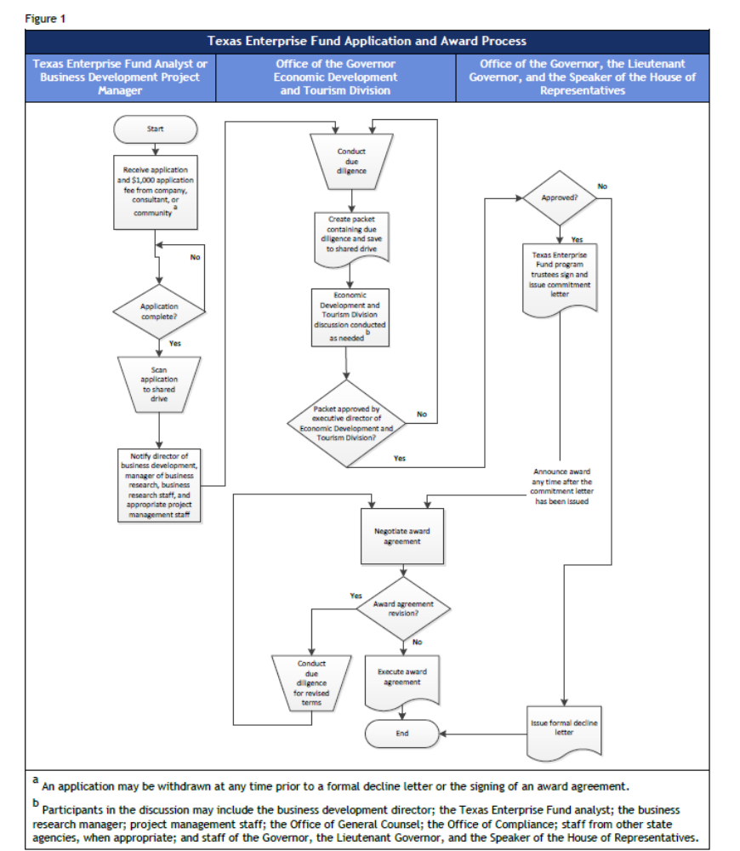

Appendix B
Texas Enterprise Fund Cost Benefit Analysis
The Cost Benefit Analysis is a scoring tool utilized by the Office of the Governor to calculate the return on investment to the state of Texas. Each application is competitive against all other applications received by the Office of the Governor. Applications that provide the greatest return of investment to the state of Texas in the least amount of time are more likely to be approved.


